NORMALIZATION

Owns:

UNF: owner-id, owner-name, owner-address, owner_ phoneNo, owner-email,r_id, r_name, r_location, r-email

1NF: Same as UNF

2NF: 1) owner-id (PK) ,owner-name, owner-address, owner-phoneNo, owner-email

2)r_id(PK),r_name,r_location,r_email,owner_id(FK)

3NF: Same as 2NF

Appoints:

UNF: owner-id, owner-name, owner-address, owner_ phoneNo, owner_email, m_id, m_name, m_salary, m_address, m_nid

1NF: Same as UNF

2NF: 1) owner-id (PK) ,owner-name, owner-address, owner-phoneNo, owner-email

2) m_id(PK),m_name, m_salary,m_address,m_nid, owner_id(FK)

3NF: Same as 2NF

Controls:

UNF: m-id ,m-name, m-address, m_salary,m_nid, s_id(PK),s_name, s_salary, s_address, s_nid,

1NF: Same as UNF

2NF: 1) m-id (PK) ,m-name, m-address, m_salary,m_nid

2) s_id(PK),s_name, s_salary,s_address,s_nid, m_id(FK)

3NF: Same as 2NF

Serves:

UNF: s_id(PK),s_name,s_salary,s_address,s_nid, g_id(PK),g_nid, g_name, g_status,g_address

1NF: Same as UNF

2NF: 1) s_id(PK),s_name,s_salary,s_address,s_nid

2) g_id(PK),g_nid,g_name,g_status,g_address

3) s_id(PK), g_id(FK)

3NF: Same as 2NF

Stays:

UNF: g_id,g_nid,g_name, g_status,g_address , room_id, room_type, availability

1NF: Same as UNF

2NF: 1) g_id(PK),g_nid,g_name,g_status,g_address

2) room_id(PK), room_type, availability

3) g_id(PK), room_id(FK)

3NF: Same as 2NF

Reserves:

UNF: g_id,g_nid,g_name, g_status,g_address , res_id, res_date

1NF: Same as UNF

2NF: 1) g_id(PK),g_nid,g_name, g_status,g_address

2) res_id(PK), res_date, g_id(FK)

3NF: Same as 2NF

Comes:

UNF: r_id, r_name, r_location, r_email,g_status, g_id,g_nid,g_name, g_status,g_address

1NF: Same as UNF

2NF: 1) r_id(PK), r_name, r_location, r_email

2) g_id,g_nid,g_name, g_status,g_address, r_id(FK)

3NF: Same as 2NF

Pays:

UNF: g_id,g_nid,g_name, g_status,g_address, p_id, p_date, p_type

1NF: Same as UNF

2NF: 1) g_id,g_nid,g_name, g_status,g_address

2) p_id(PK), p_date, p_type, g_id(FK)

3NF: Same as 2NF

FINALIZATION

1. owner-id (PK) ,owner-name, owner-address, owner-phoneNo, owner-email
2. r_id(PK),r_name,r_location,r_email,owner_id(FK)
3. ~~owner-id (PK) ,owner-name, owner-address, owner-phoneNo, owner-email~~
4. m_id(PK),m_name, m_salary,m_address,m_nid, owner_id(FK)
5. m-id (PK) ,m-name, m-address, m_salary,m_nid
6. s_id(PK),s_name, s_salary,s_address,s_nid, m_id(FK)
7. s_id(PK),s_name,s_salary,s_address,s_nid
8. g_id(PK),g_nid,g_name,g_status,g_address
9. s_id(PK), g_id(FK)
10. ~~g_id(PK),g_nid,g_name,g_status,g_address~~
11. room_id(PK), room_type, availability
12. g_id(PK), room_id(FK)
13. ~~g_id(PK),g_nid,g_name, g_status,g_address~~
14. res_id(PK), res_date, g_id(FK)
15. r_id(PK), r_name, r_location, r_email
16. g_id,g_nid,g_name, g_status,g_address, r_id(FK)
17. ~~g_id,g_nid,g_name, g_status,g_address~~
18. p_id(PK), p_date, p_type, g_id(FK)

FINAL TABLE

1. owner_id (pk), owner_name, owner_address, owner_phoneNo, owner_email (owner)
2. m_id (pk), m_name, m_salary, m_address, m_nid (manager)
3. s_id(pk), s_name, s_nid, s_address, s_salary (staff)
4. g_id(pk), g_nid, g_name, g_status, g_address (guest)
5. room_id(pk), room_type, availability (room)
6. res_id (pk), res_date, g_id(fk) (resort)
7. r_id, r_name, r_location, r_email, owner_id (fk) (own)
8. m_id (pk), m_name, m_salary, m_address, m_nid, owner_id(fk) (appoint)
9. s_id(pk), s_name, s_nid, s_address, s_salary, m_id(fk) (control)
10. s_id (pk), g_id(fk) (serve)
11. g_id(pk), room_id(fk) (stay)
12. res_id (pk), res_date, g_id(fk) (reserve)
13. g_id (pk), g_status, g-address, g_name, g_nid, r_id(fk) (come)
14. p_id (pk), p_date, p_type, g_id (fk) (pay)

TABLE CREATION

OWNER:

MANAGER:

STAFF:

GUEST:

ROOM:

RESORT:

OWN:

APPOINT:

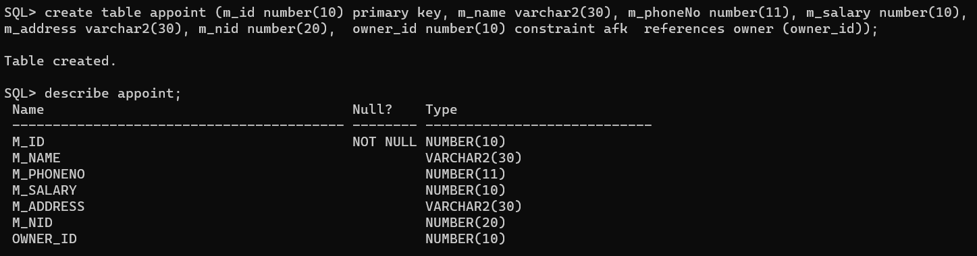

CONTROL:

SERVE:

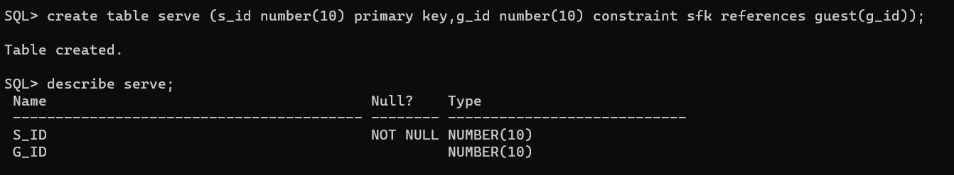

STAY:

RESERVE:

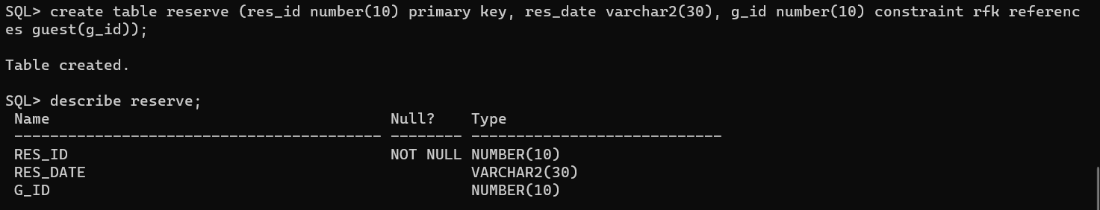

COME:

PAY:

VALUE INSERTION

OWNER:



MANAGER:

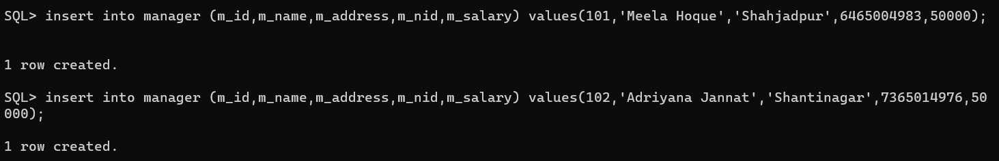

STAFF:

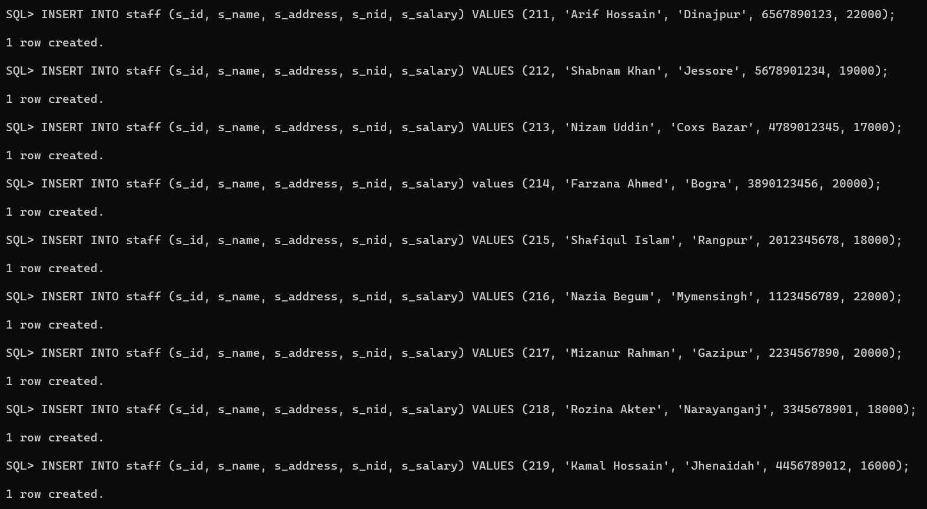

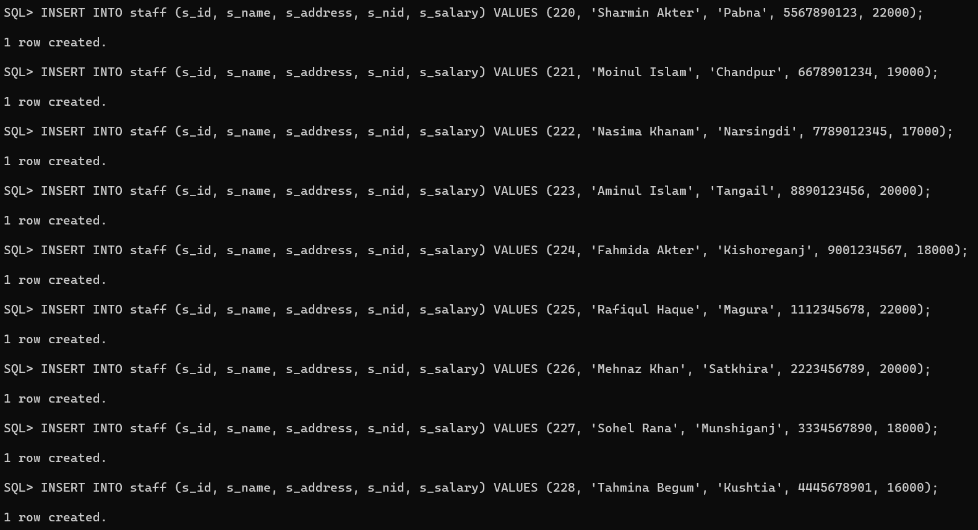

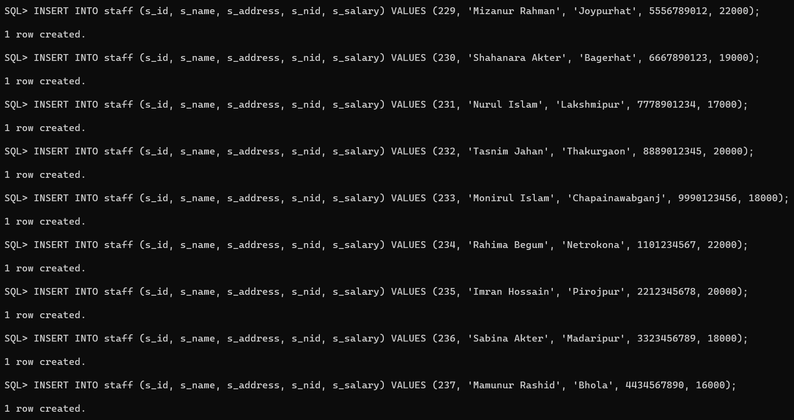

GUEST:

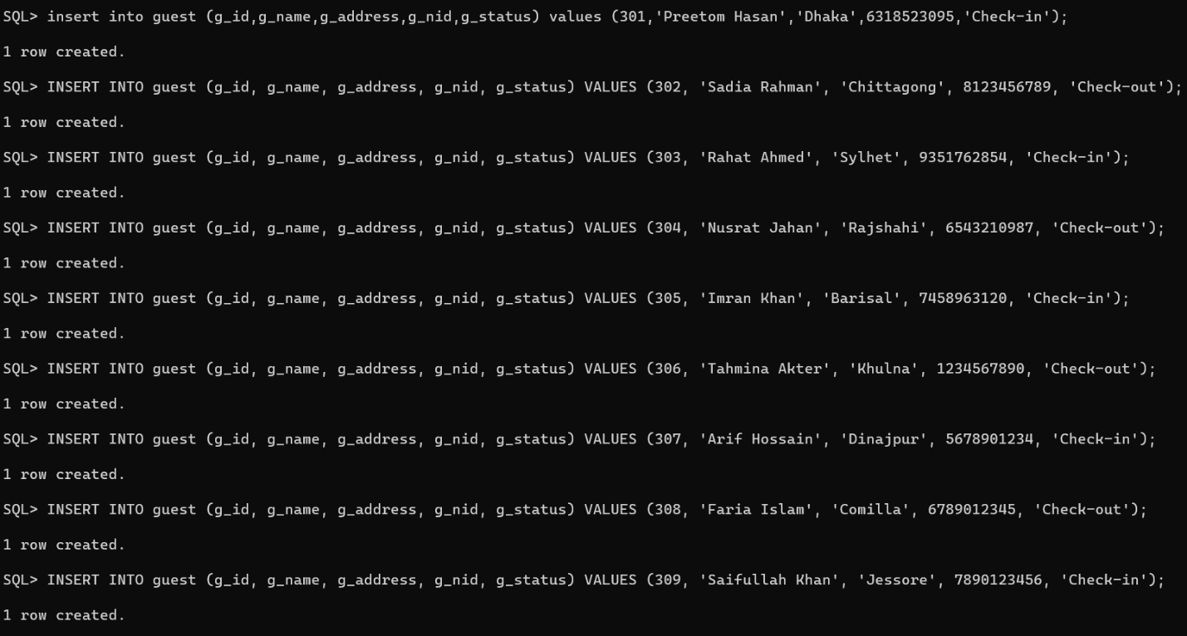

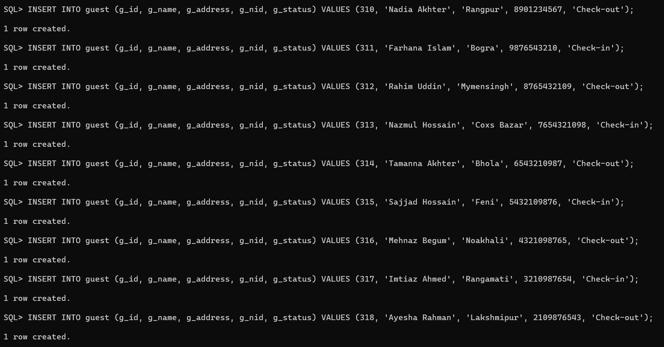

ROOM:

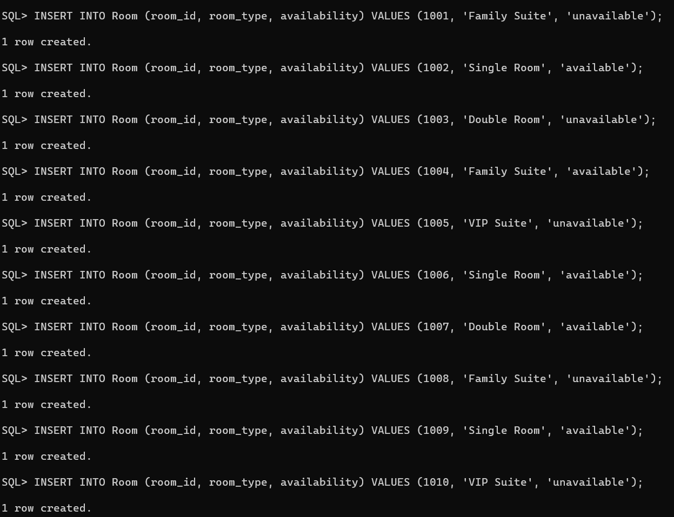

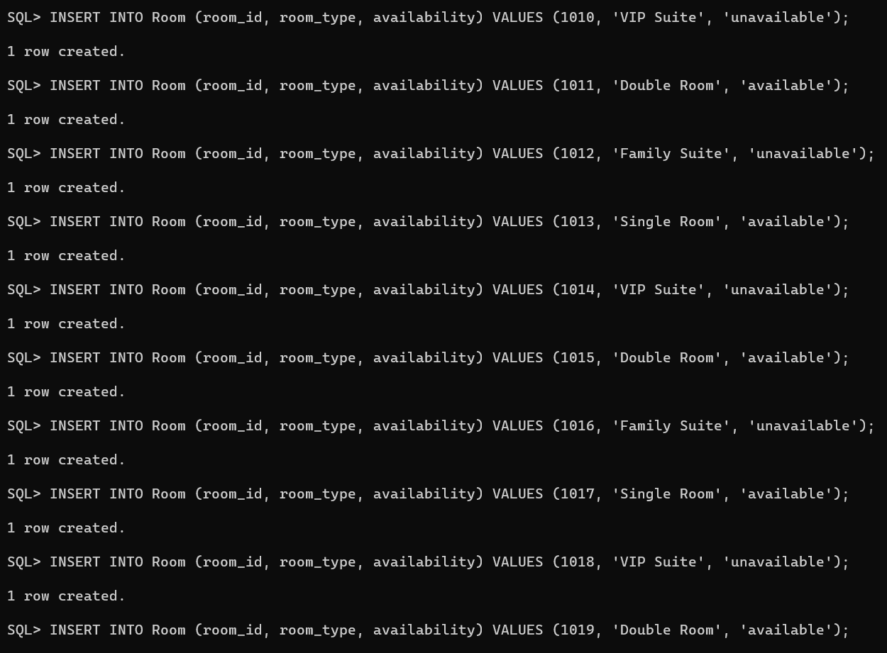

RESORT:



OWN:



APPOINT:

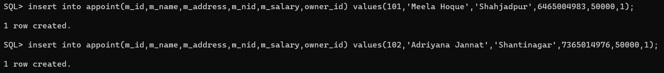

CONTROL:

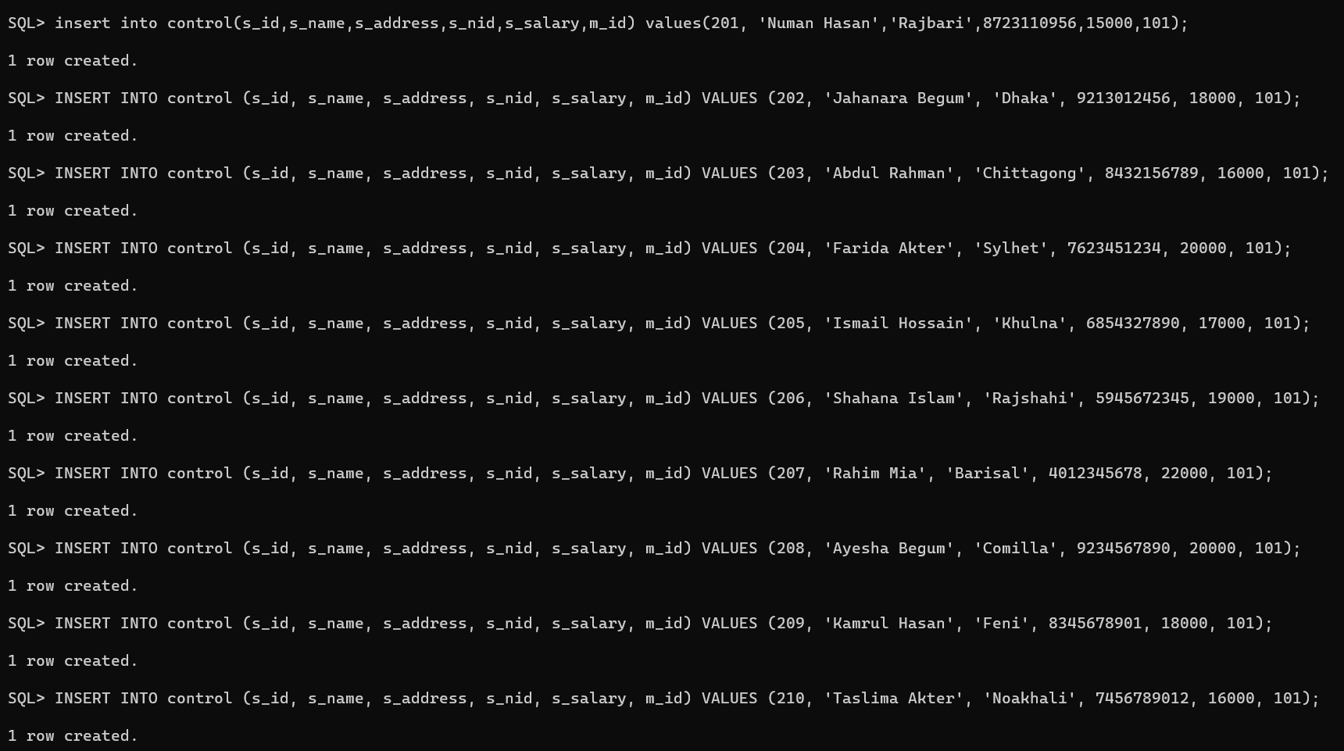

SERVE:

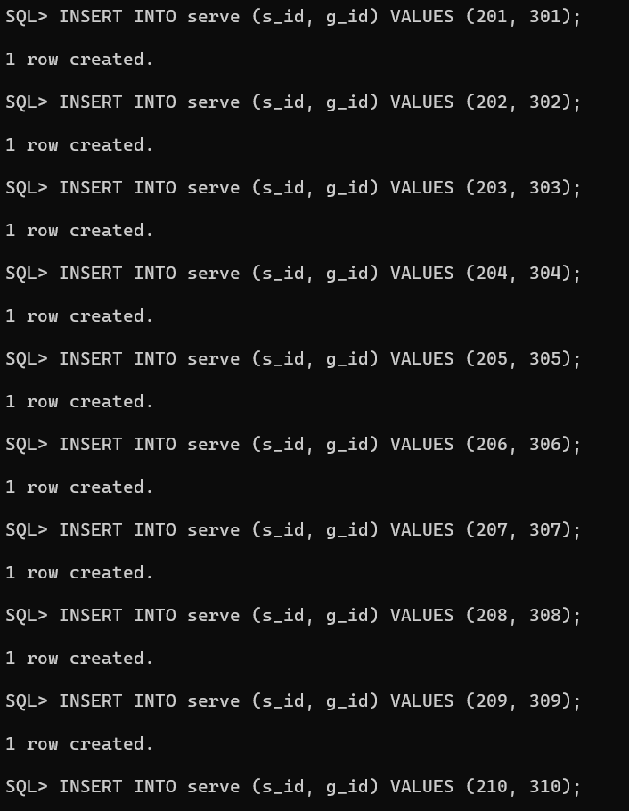

STAY:

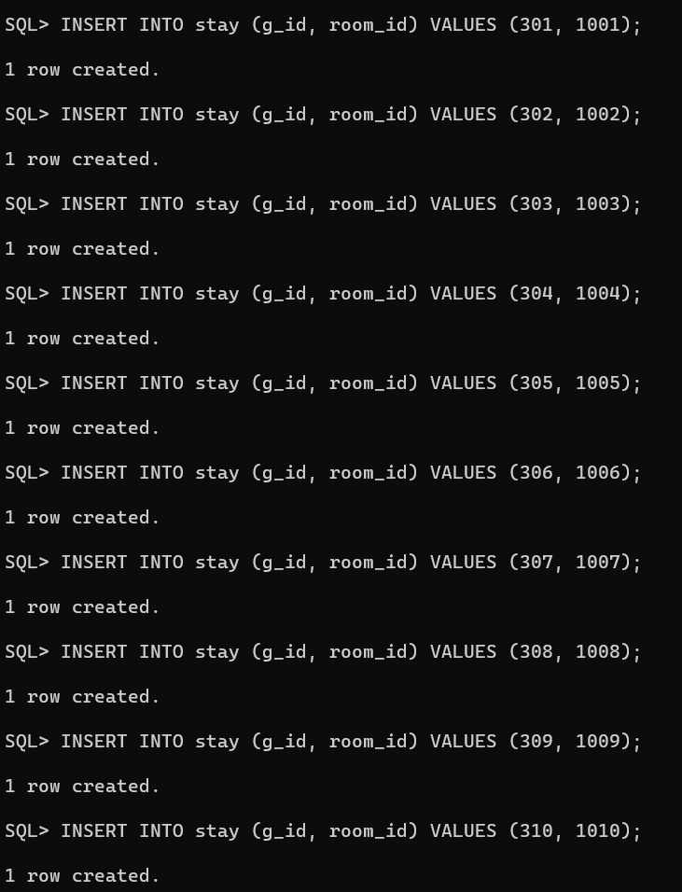

RESERVE:

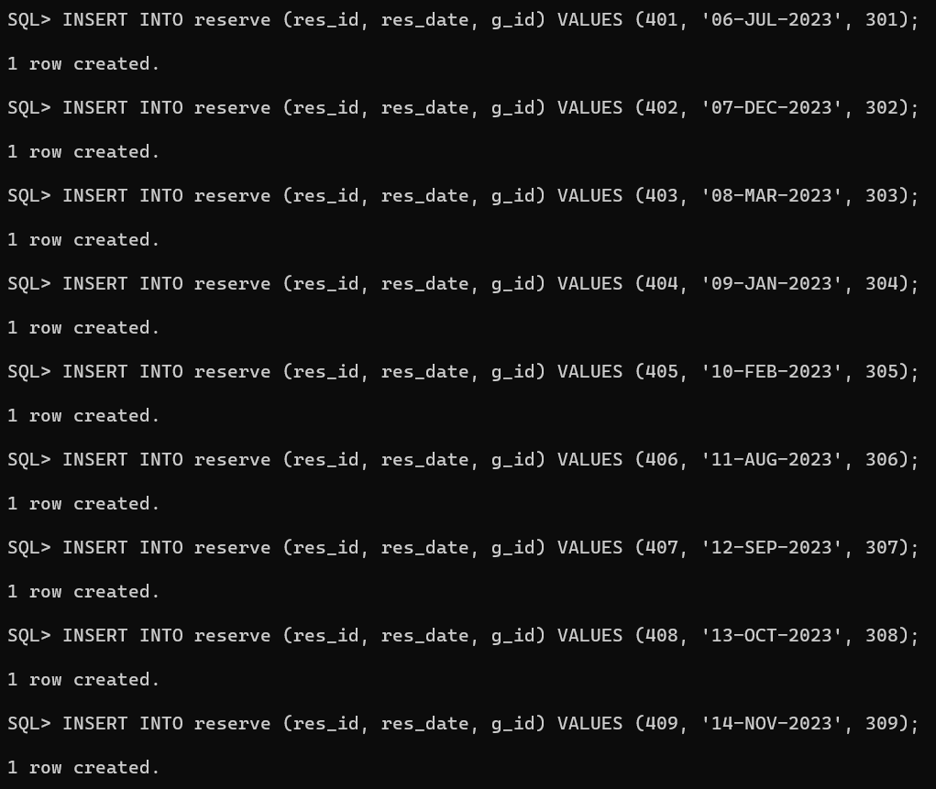

COME:

PAY:

